Changes needed for ESRFileEncryptor Application

Below is the current design:
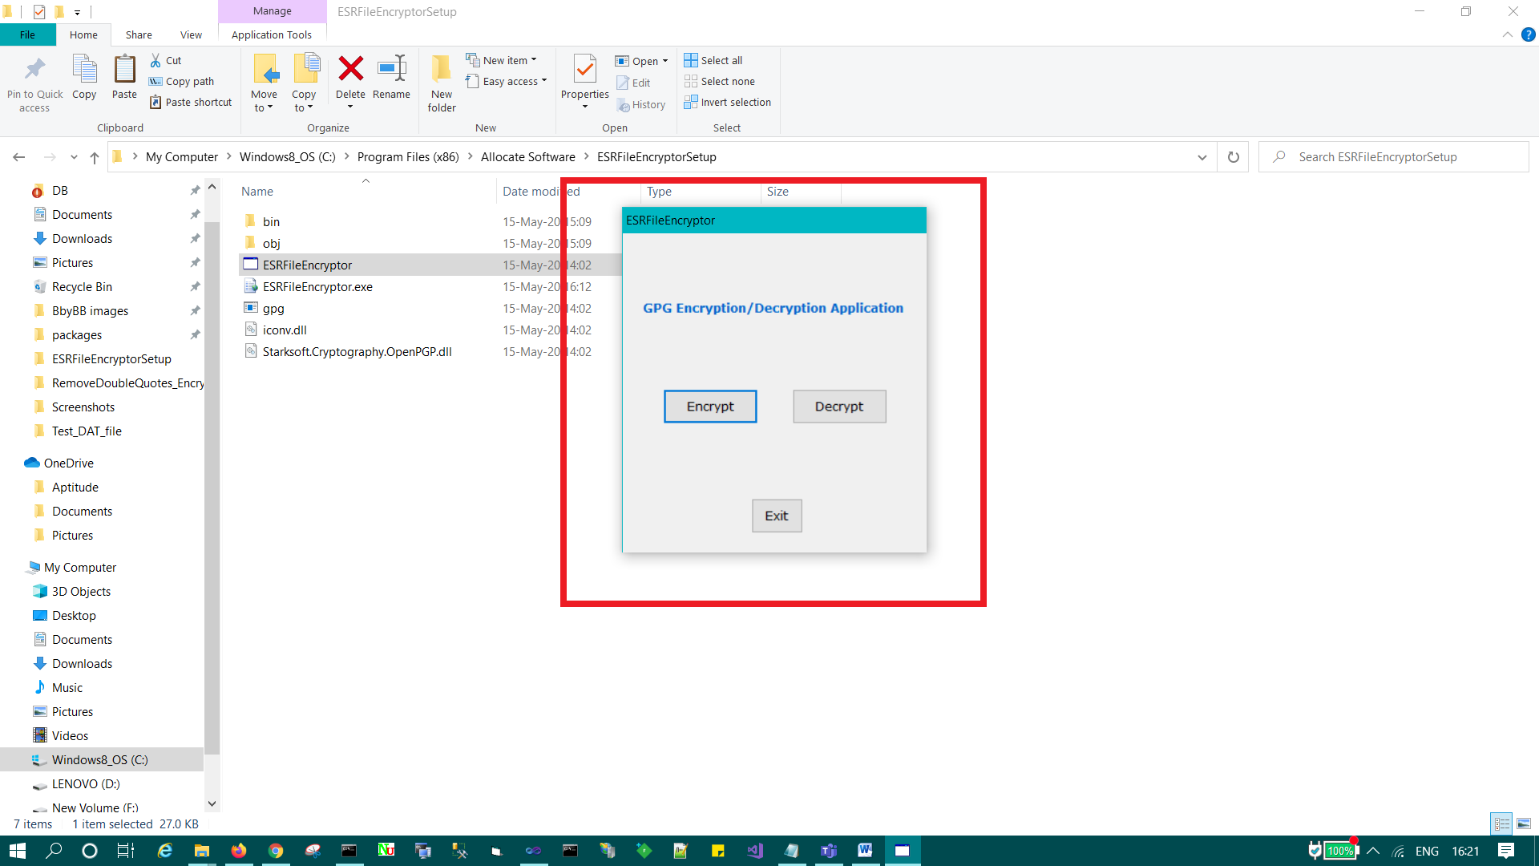

Points noted after the discussion:
- Size of application to be little bigger much like other standalone applications.
- Change the Application header (ESRFileEncryptor), if Matt has suggested anything.
- Change the Display Text, to make it more understandable (In the future).

Below is the current encryption message we get after successful encryption:
(We can change it)
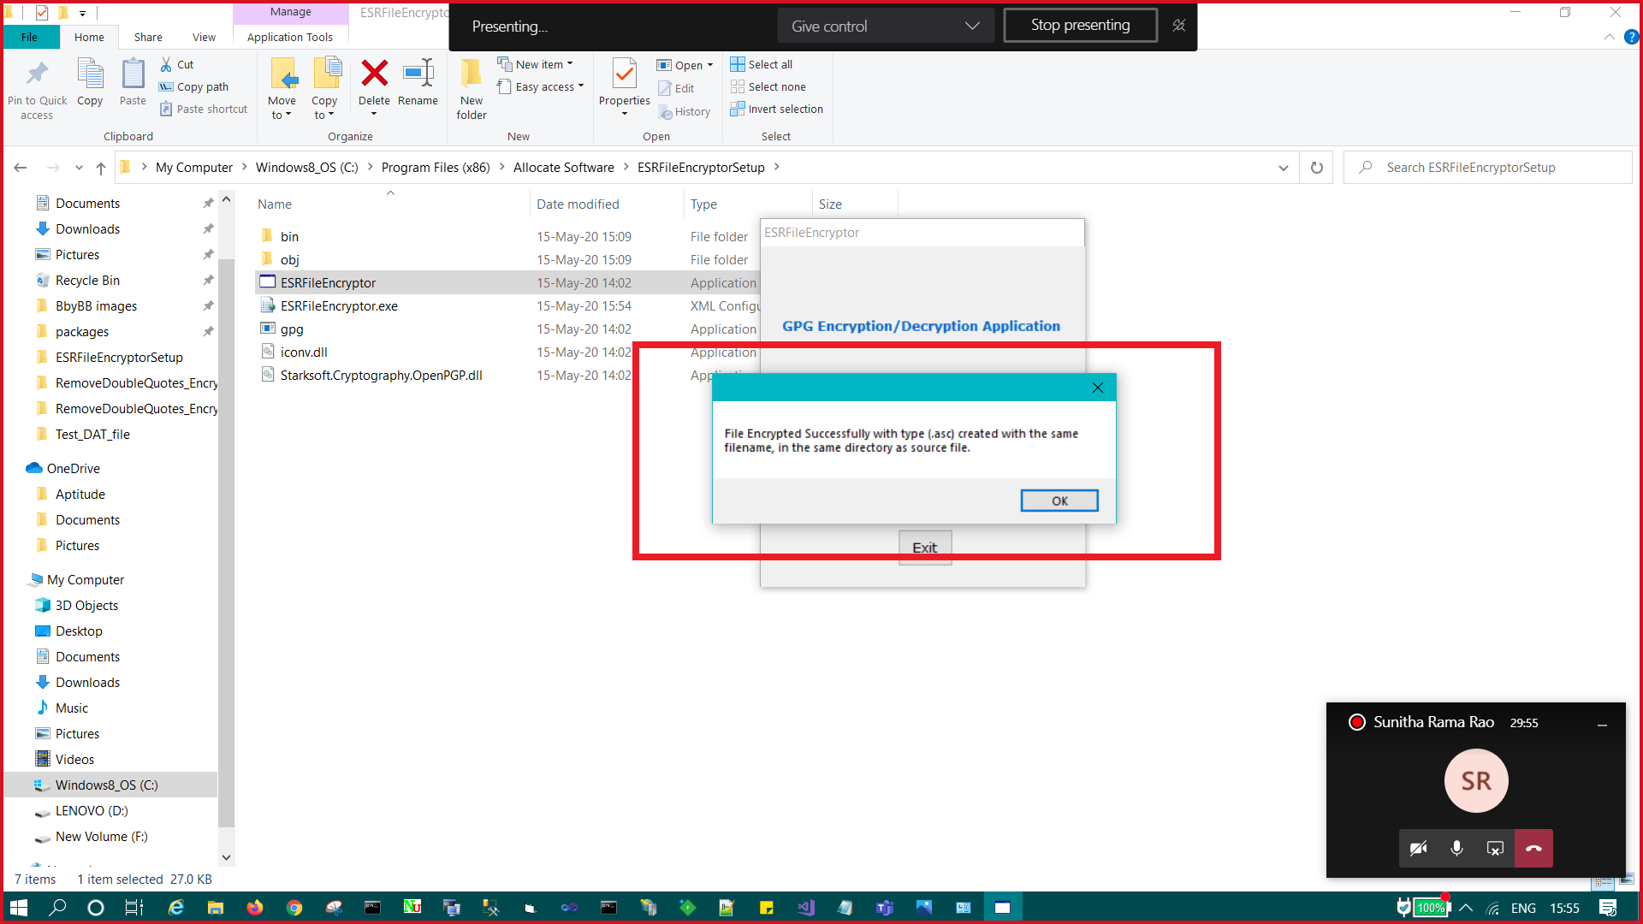
Below is the current decryption message we get after successful decryption:
(We can change it)
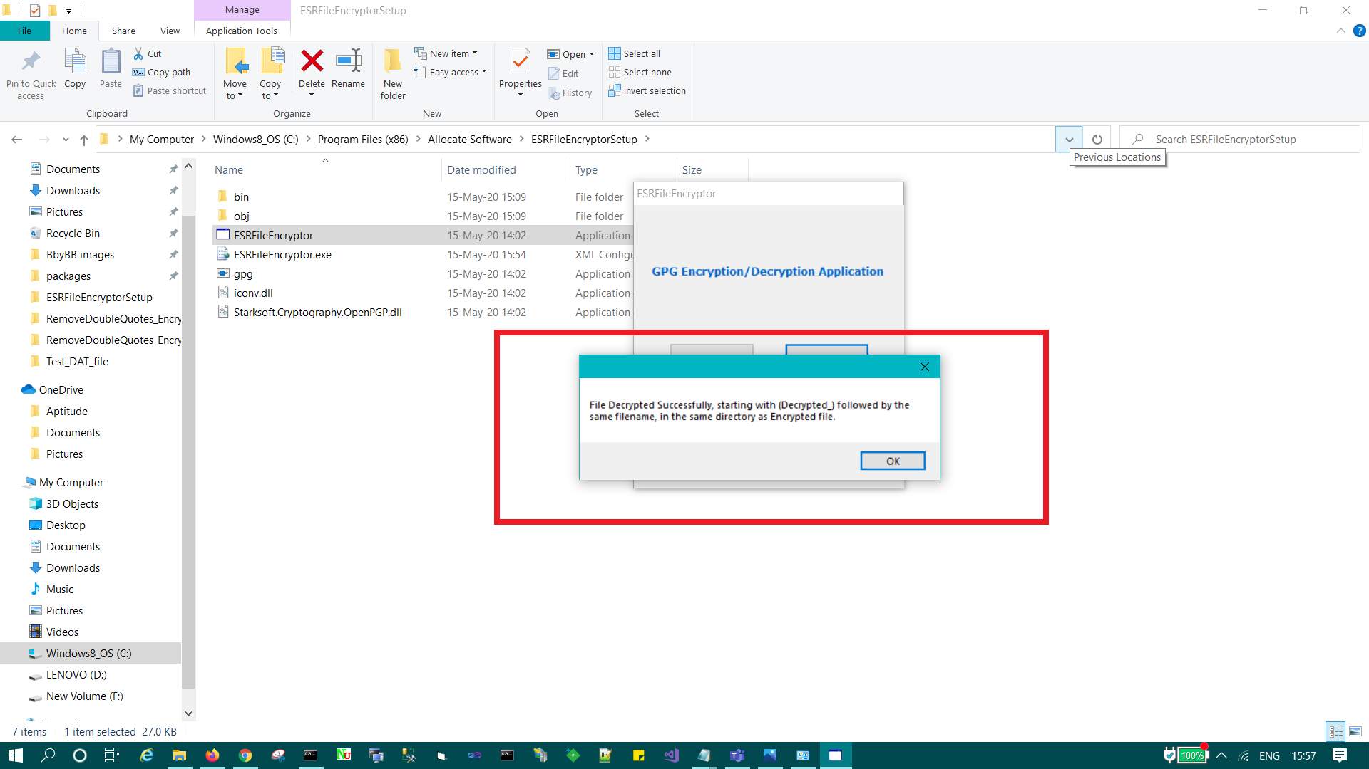
Below is the error message we get if no or incorrect secret key in the app.config file:
(We can’t change it, it comes from gpg exe)
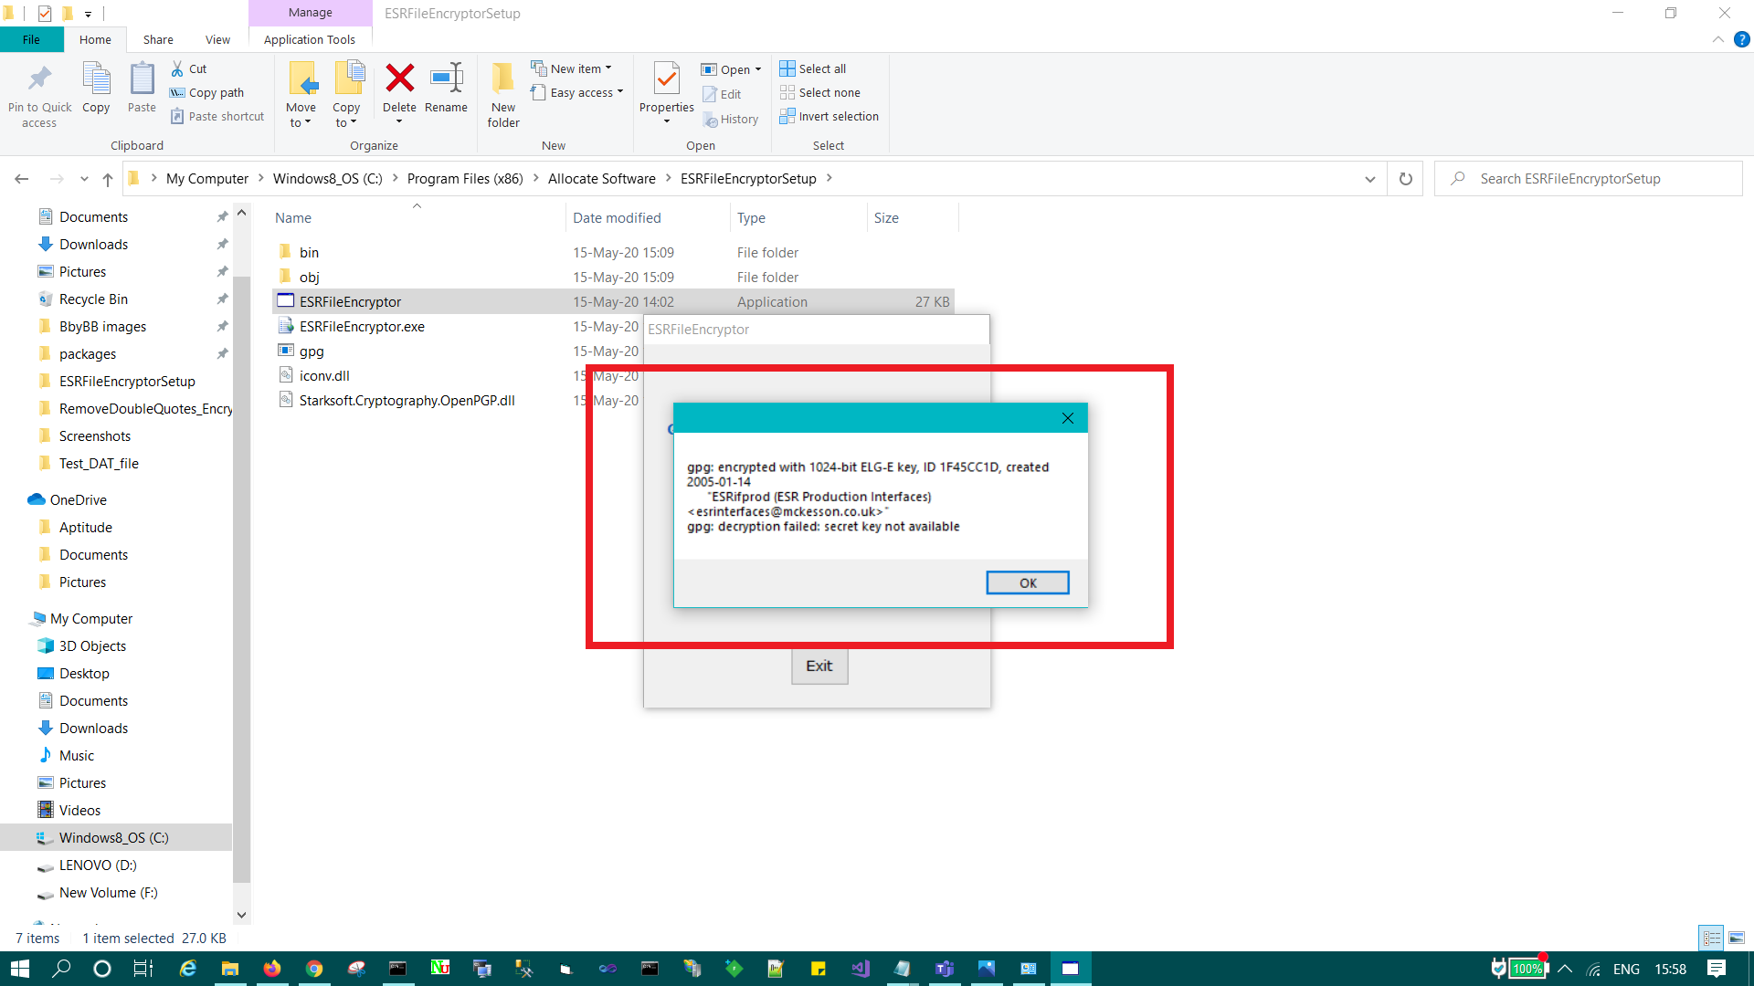
Below is the error message we get if no public key given in app.config file:
(We can change it)
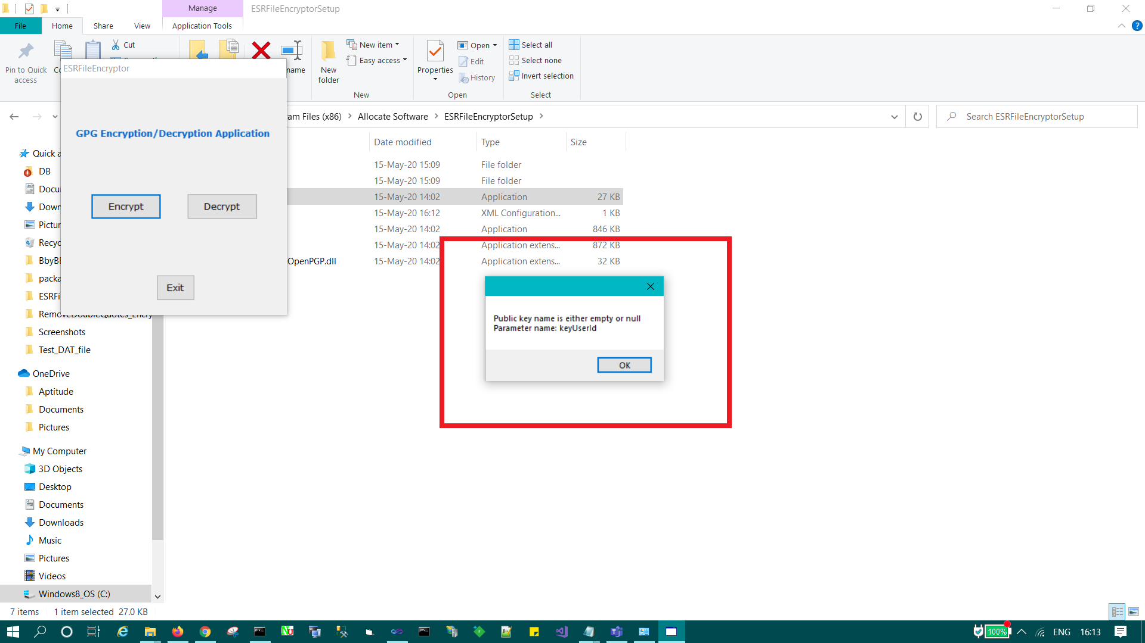
Below is message we get if we don’t select a file to encrypt: (we can change it)
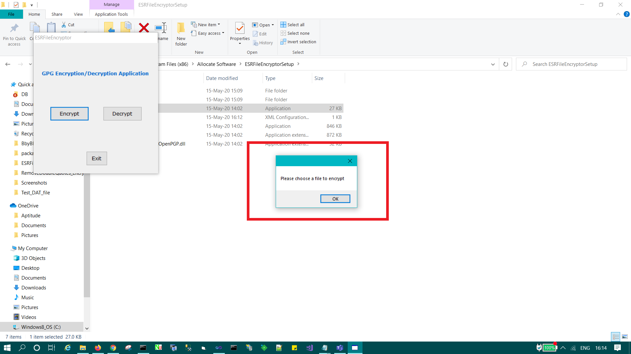
Below is message we get if we don’t select a file to decrypt: (we can change it)
